**CS 155 Project 2 Ray Tracing**

Xiaotian Wang

**1 Late Day Used**

1. Feature implemented

|  |  |  |
| --- | --- | --- |
| **Part I: Ray Casting** | | |
| **If Completed** | **Function Name** | **Points** |
| Y | Cast rays into the scene | 5 |
| Y | Intersections with spheres | 5 |
| Y | Intersections with triangles | 5 |
| Y | Add a primitive | 5 |
| Y | Transformations | 10 |
| Y | Part I tests | 5 |
|  |  |  |
| **Part II: Recursion and Lights** | | |
| Y | Reflection | 10 |
| Y | Transmission | 10 |
| Y | Snell's Law | 5 |
| Y | Point Lights | 5 |
| Y | Emissive and Ambient | 2 |
| Y | Part II tests | 5 |
|  |  |  |
| **Part III: Bells and Whistles** | | |
| Y | Texture mapping | 5 |
| Y | Bump Mapping | 8 |
| Y | Spot Lights | 5 |
| Y | Procedural Textures | 10 |
| Y | Jittering / Soft Shadows / Depth of Field | 5 |
| Tried | Add another primitive: cylinder | 5 |
| N | Torus Primitive | 10 |
| Y | Fisheye Lens | 5 |
| N | Lens flare/bloom | 5 |
| N | Cool ray file | 2 |
| N | Impress us with something we hadn't considered | ? |
| Y | Submit an entry to the art contest | 5 |
| Y | Submit an interesting MPEG movie made from multiple raytraced images | 10 |

1. Test cases
2. Sphere

OpenGL ray tracer

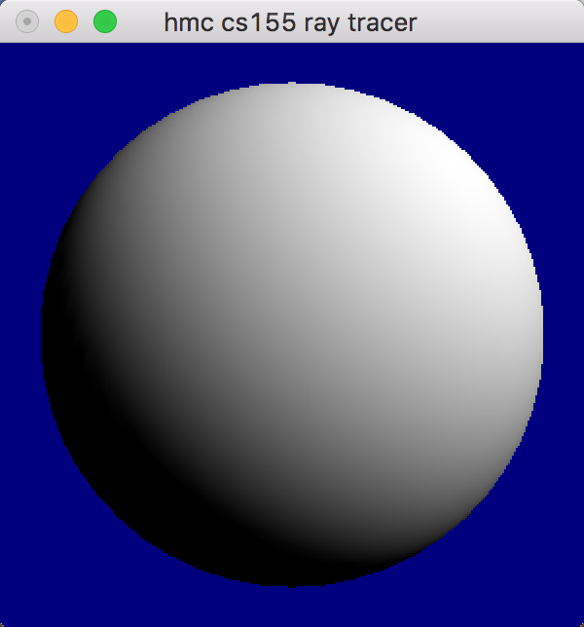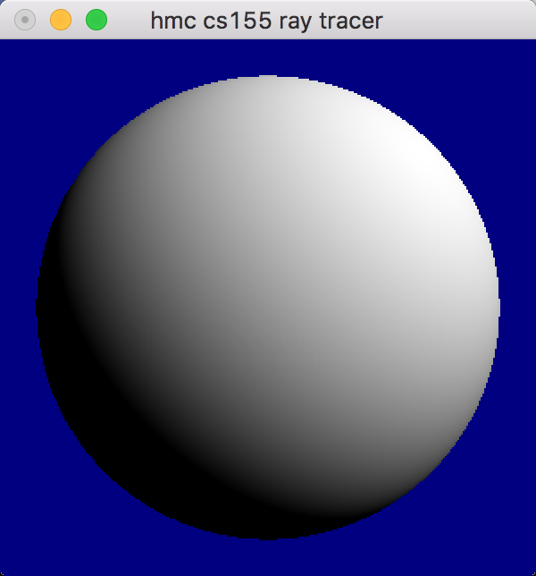

1. Triangle

OpenGL ray tracer

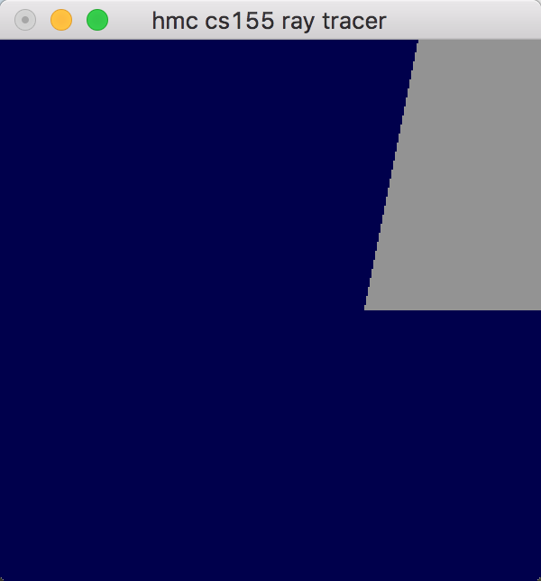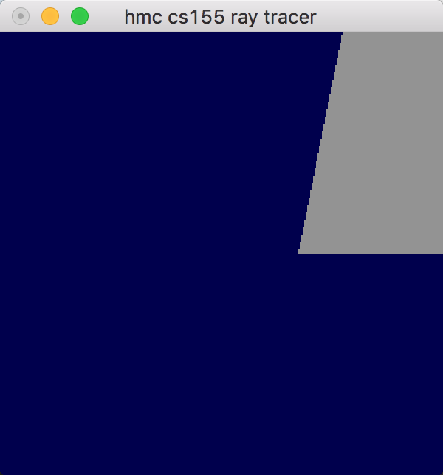

1. Xfm

OpenGL ray tracer

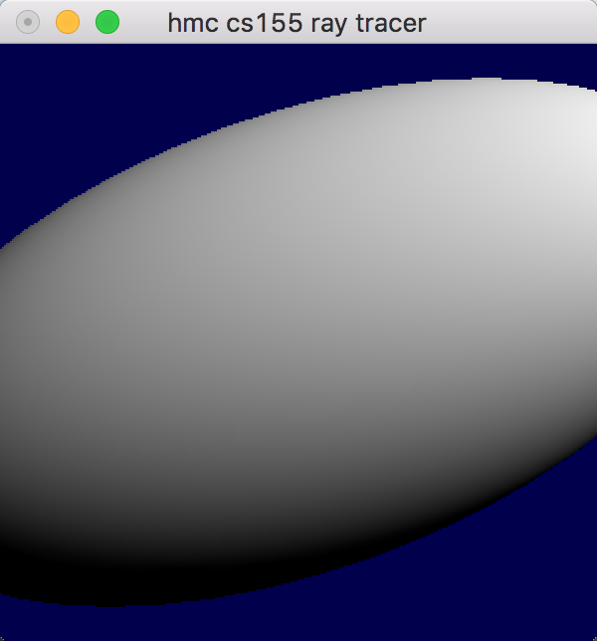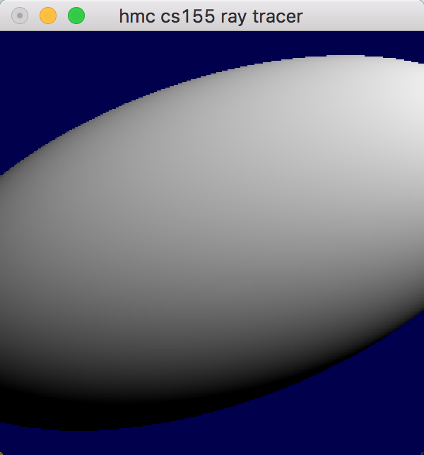

1. Group

OpenGL ray tracer

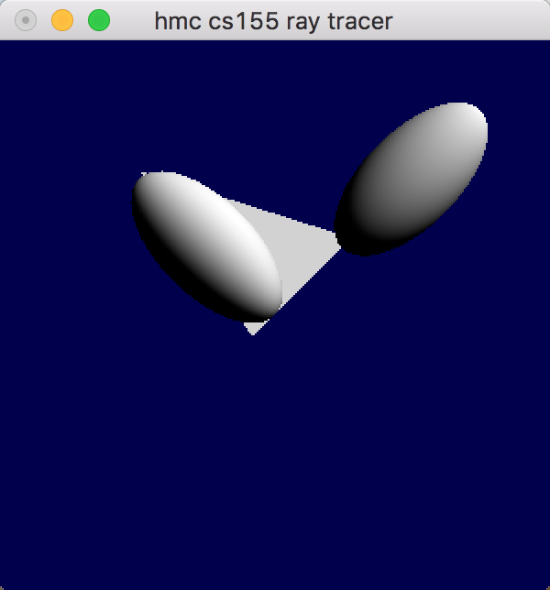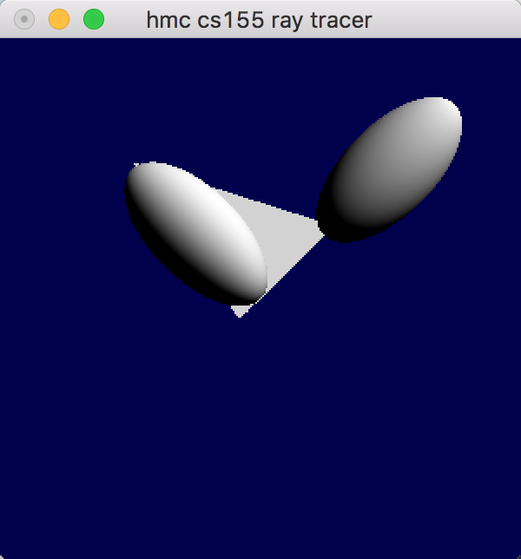

1. Ambient Emissive

OpenGL ray tracer

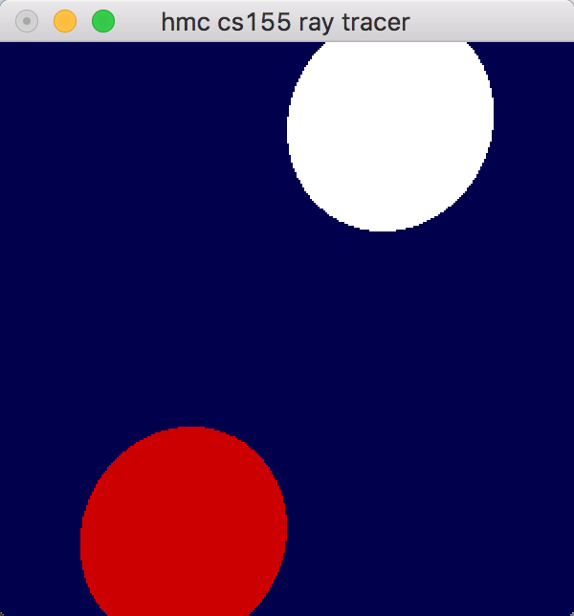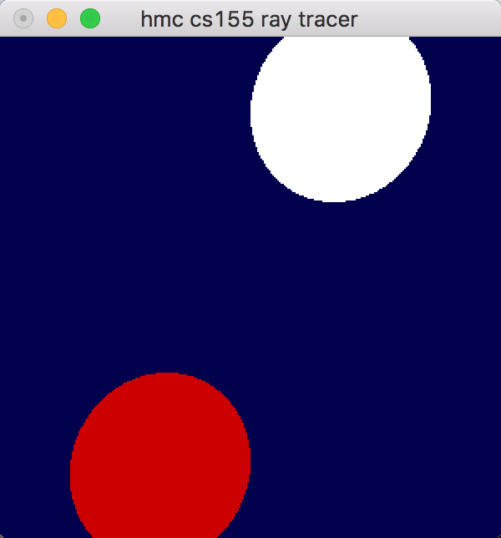

1. Shadow

OpenGL ray tracer

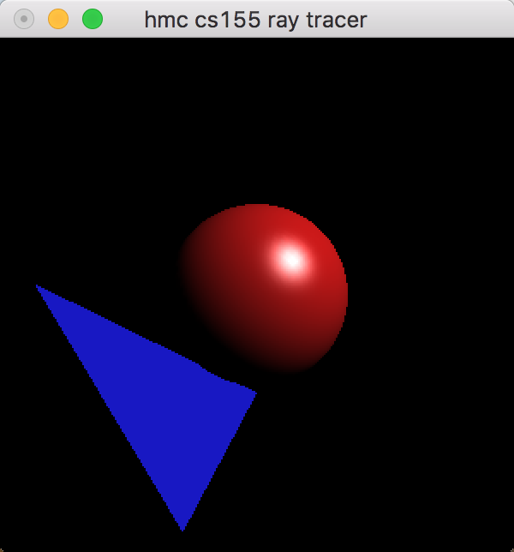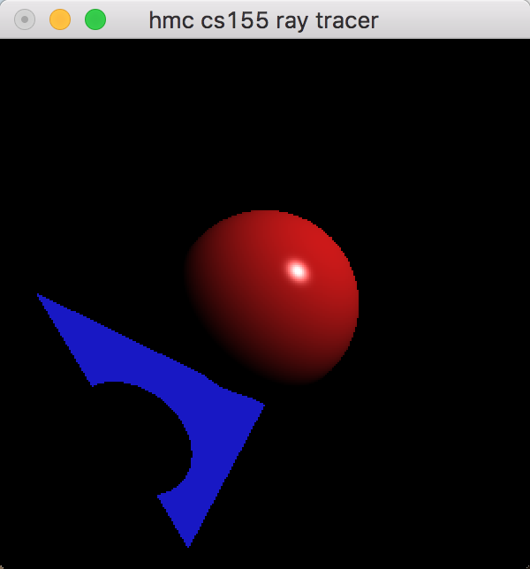

1. Reflect

OpenGL ray tracer

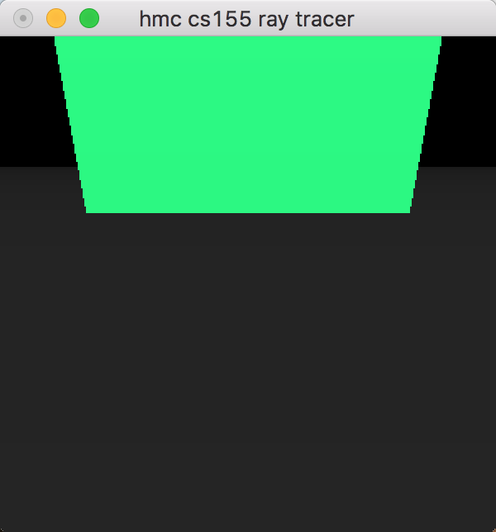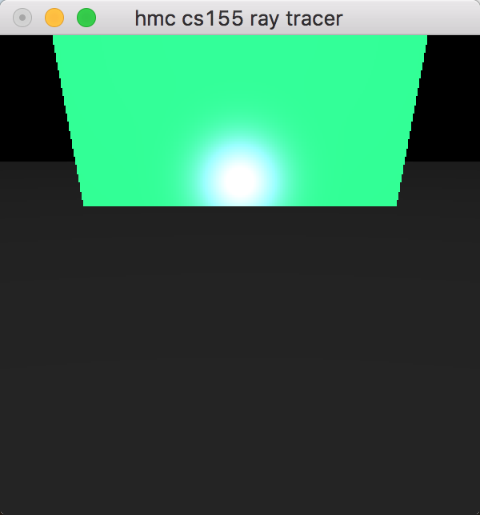

1. Transmit

OpenGL ray tracer

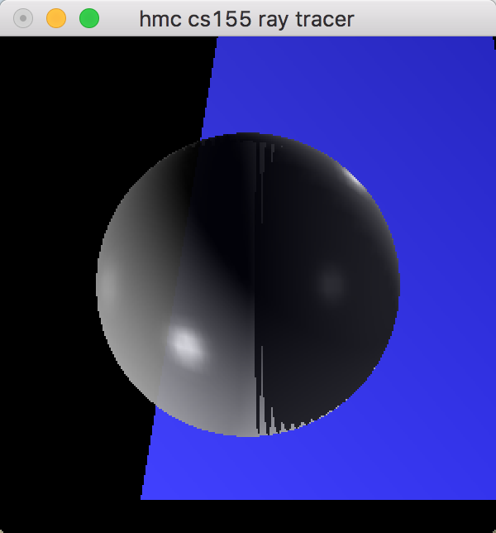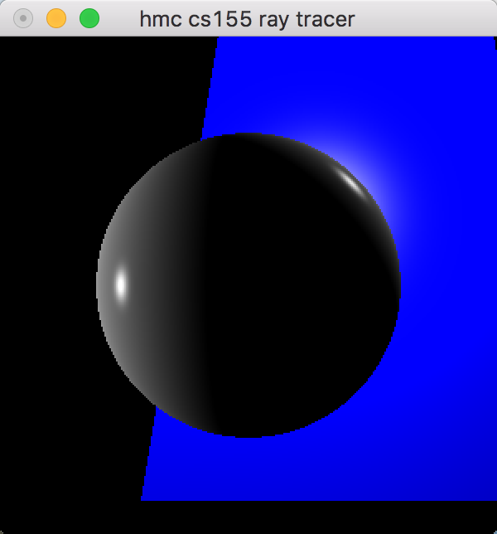

1. Refract

OpenGL ray tracer

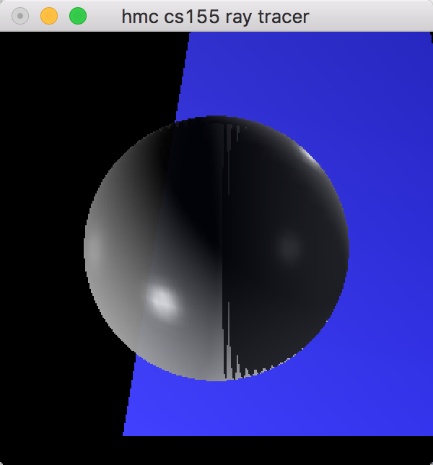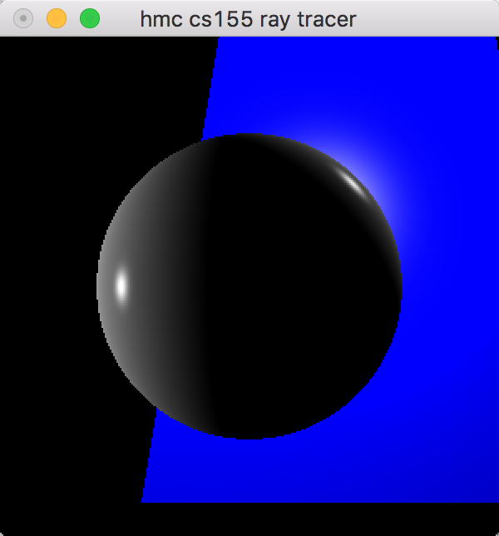

1. Texture

OpenGL ray tracer

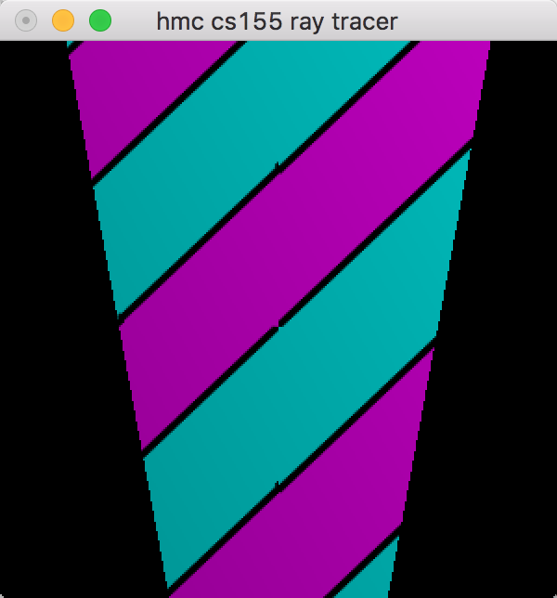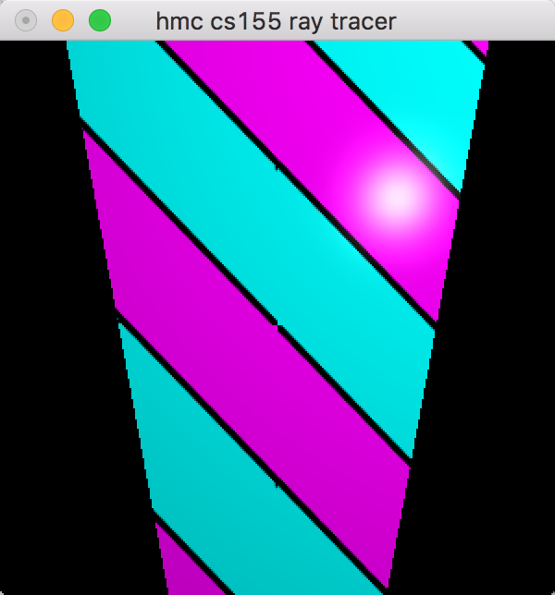

1. Point Light

OpenGL ray tracer

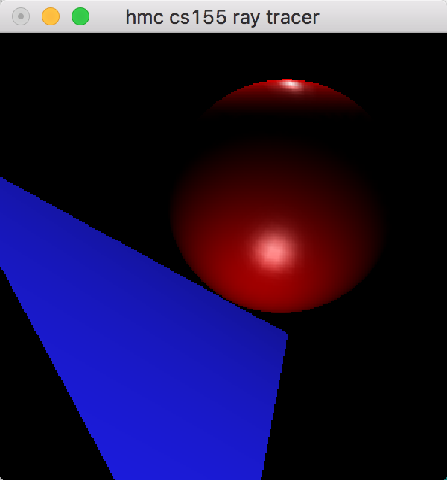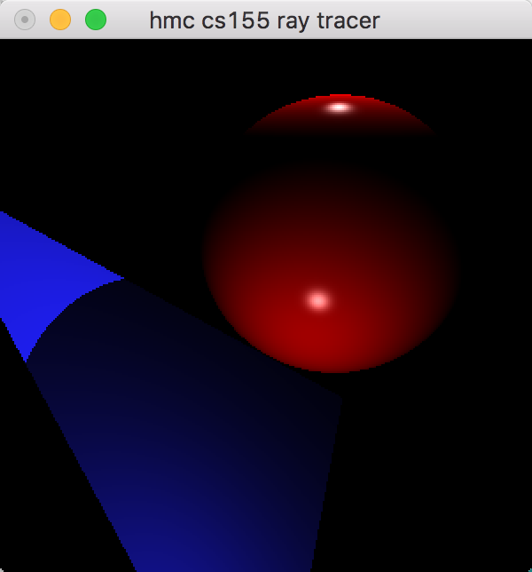

1. Texture

OpenGL ray tracer

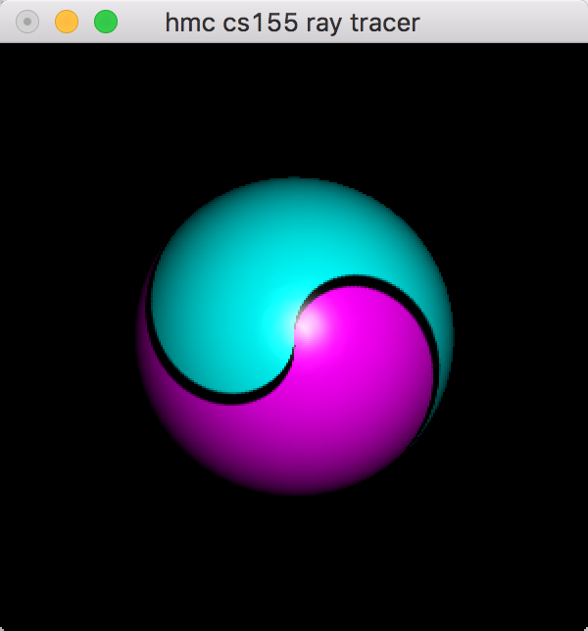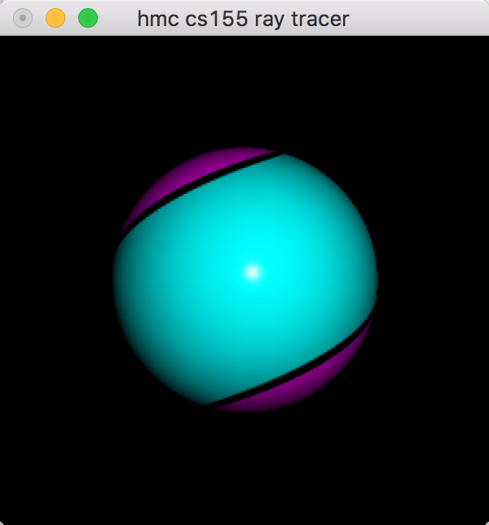

1. Spot

OpenGL ray tracer

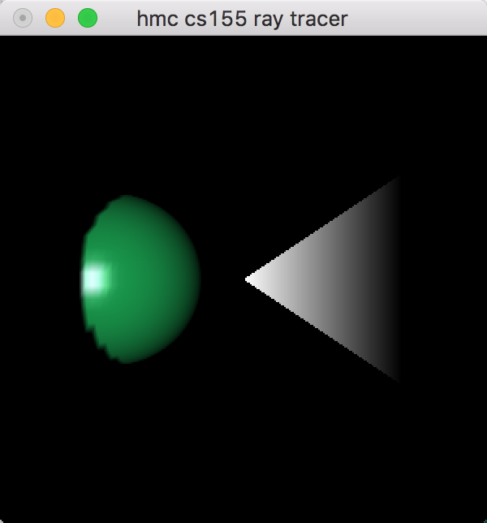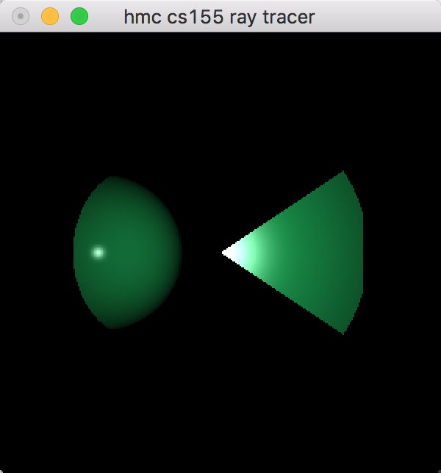

1. Box

OpenGL ray tracer

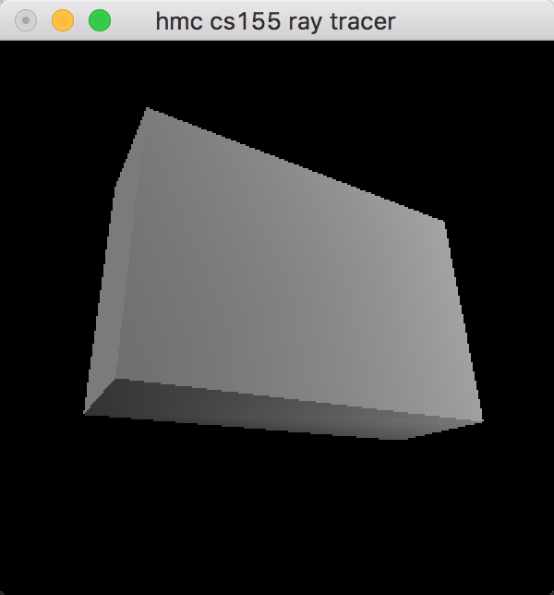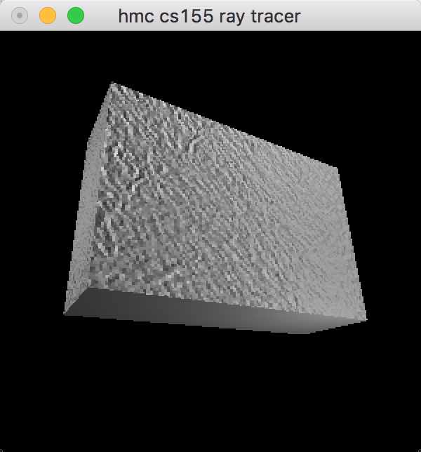

ray tracer

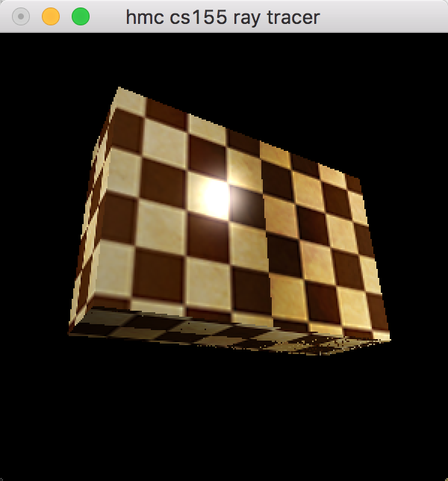

1. Bump

OpenGL ray tracer

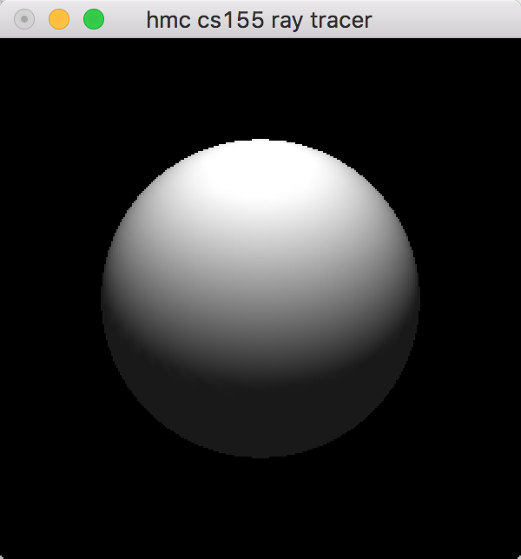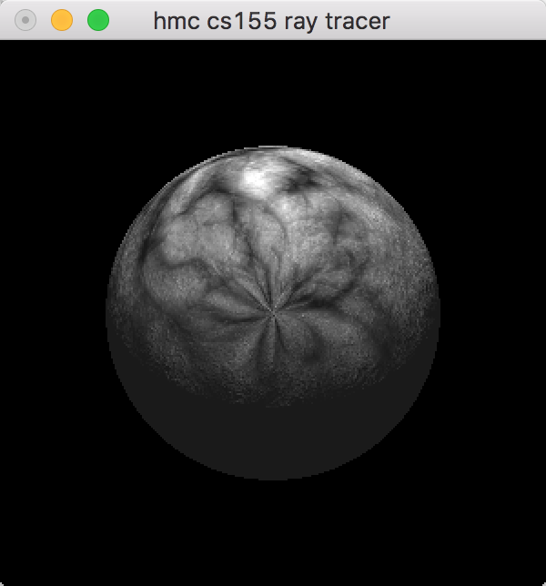

1. Fisheye (compromised) – reflect.bmp

OpenGL ray tracer

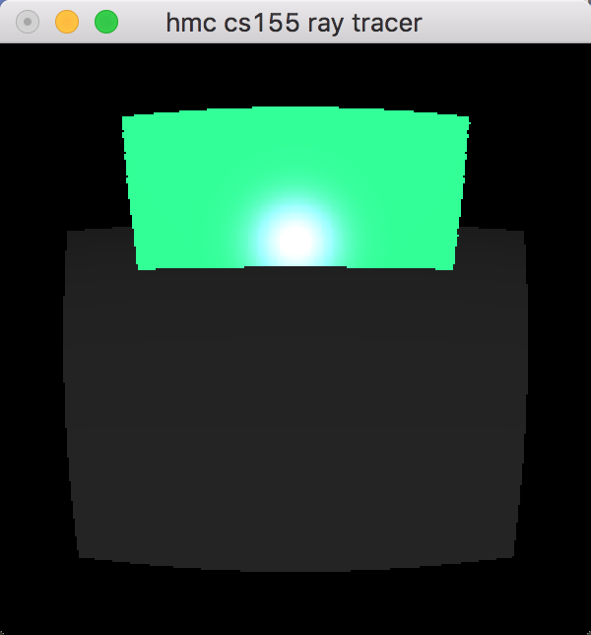

1. Jittering (jitter rays: 3) – reflect.bmp

OpenGL ray tracer

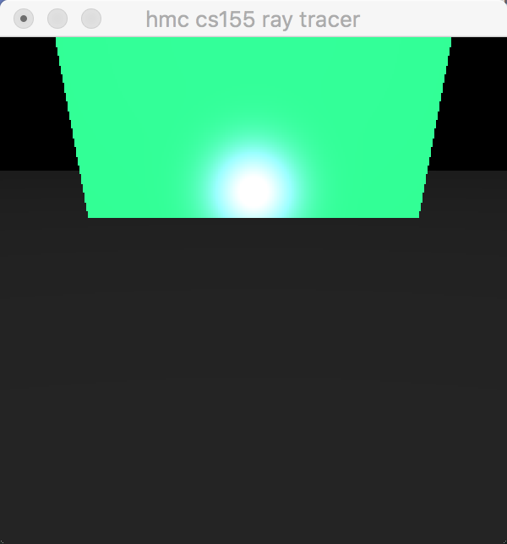

1. Perlin Noise (Procedural texture) – box.bmp

OpenGL ray tracer

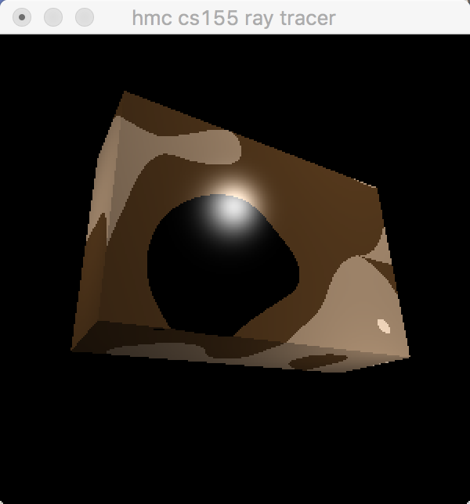

1. Known bugs

There are no known bugs.